COMPUTER LABORATORY MANUAL

 | 

Machine Learning
(CS – 471)

DEPARTMENT OF COMPUTER SOFTWARE ENGINEERING
Military College of Signals
National University of Sciences and Technology
www.mcs.nust.edu.pk
PREFACE
This lab manual has been prepared to facilitate the students of Computer Software Engineering in studying and analyzing various tools and concepts of Machine Learning. Generally, Machine learning is a branch of artificial intelligence (AI) and computer science which focuses on the use of data and algorithms to imitate the way that humans learn, gradually improving its accuracy. Machine learning is an important component of the growing field of data science. Through the use of statistical methods, algorithms are trained to make classifications or predictions, uncovering key insights within data mining projects. These insights subsequently drive decision making within applications and businesses, ideally impacting key growth metrics. As big data continues to expand and grow, the market demand for data scientists will increase, requiring them to assist in the identification of the most relevant business questions and subsequently the data to answer them. Students will be able to understand the underlying mathematical relationships within and across Machine Learning algorithms and design and implement various machine learning algorithms in a range of real-world applications.
PREPARED BY
Lab manual is prepared by Assoc Prof Dr. Hammad Afzal and Lab Engr Saba Siddique.
GENERAL INSTRUCTIONS
- Students are required to maintain the lab manual with them till the end of the semester.
- All readings, answers to questions and illustrations must be solved on the place provided. If more space is required, then additional sheets may be attached.
- It is the responsibility of the student to have the manual graded before deadlines as given by the instructor
- Loss of manual will result in re submission of the complete manual.
- Students are required to go through the experiment before coming to the lab session. Lab session details will be given in training schedule.
- Students must bring the manual in each lab.
- Keep the manual neat clean and presentable.
- Plagiarism is strictly forbidden. No credit will be given if a lab session is plagiarized and no re submission will be entertained.
- Marks will be deducted for late submission.
- Error handling in a program is the responsibility of the student.

VERSION HISTORY
Date | Update By | Details
October 2022 | Dr. Hammad Afzal, Lab Engr Saba Siddique | v1
January 2024 | LE Sumaya Amin | V2
May 2025 | Dr. Naima Iltaf, LE Shehla Farooq | V3 (Updated titles and objectives of all labs, also changed the formatting of whole document)
Mapping of Lab Experiments
Criteria | Unacceptable  (Marks=0) | Substandard  Marks=1 | Adequate  Marks=2 | Proficient  Marks=3
R1  Completeness  And Accuracy | The program failed to produce the right accurate result | The program execution let to inaccurate or incomplete results. It was not correctly functional or not all the features were implemented | The program was correctly functional and most of the features were implemented | The program was correctly functional, and all the features were implemented
R2  Syntax and Semantics | The student fails to figure out the syntax and semantic errors of the incorrect program | Student successfully figures out few of syntax and semantic errors of the program with extensive guidance | Student successfully figures out most of syntax and semantic errors of the program with minimum guidance | Student successfully figures out all syntax and semantic errors of the program without any guidance
R3  Demonstration | Student failed to demonstrate a clear understanding of the assigned task | Student has basic understanding, but asked questions were not answered. | Student has basic knowledge of understanding. Provides fundamental answers to asked questions | Student has demonstrated on accurate understanding of the lab objective and concepts. All the questions are answered completely and correctly
R4  Complexity and Readability | The code is poorly organized and very difficult to read | The code is readable only by someone who knows what it is supposed be doing | The code is fairly easy to read | The code is exceptionally well organized and very easy to follow
R5  Perseverance and plagiarism | Complete working program is copied indicating no effort on student’s part resulting in a total score of zero for all rubrics | Most of working program is copied. Minor contribution by the student | Most of working program is contributed by the student. Minor copied components | Complete working program is contributed by the student
Lab Rubrics (Group 1)

COURSE LEVEL OUTCOMES
Course Outcomes:
At the end of this course, the students will be able to attain the CLOs in the table below.
Sr No. | CLO | PLO | BT Level*
1 | Understand the underlying mathematical relationships within and across Machine Learning algorithms | 1 | C-2
2 | Demonstrate the concepts and design choices for various machine learning algorithms such as regression, decision tree, Neural Networks, SVMs etc | 2 | C-3
3 | Design and evaluate machine learning models to solve real-world problems. | 3 | C-5
4 | Implement various machine learning algorithms in a range of real-world applications. | 5 | P-5

Mapping of CLOs to Program Learning Outcomes
PLOs/CLOs | CLO1 | CLO2 | CLO3 | CLO4
PLO 1 (Engineering Knowledge) | √
PLO 2 (Problem Analysis) |  | √
PLO 3 (Design/Development of Solutions) |  |  | √
PLO 5 (Modern tool usage) |  |  |  | √

S No | List of Experiments | CLO | R-G
1 | Practical Implementation of Data Preprocessing Techniques for Machine Learning | 4 | 1
2 | Hands-on Implementation of Data Preprocessing Techniques Using Key Python Libraries | 4 | 1
3 | Design and Implementation of Linear Regression and Gradient Descent for Supervised Learning Tasks | 4 | 1
4` | Design and Implementation of Polynomial Regression for Modeling Non-Linear Relationships | 4 | 1
5 | Development and Implementation of Logistic Regression for Classification Tasks | 4 | 1
6 | Design and Implementation of Support Vector Classification | 4 | 1
7 | Design and Implementation of Non-Linear Support Vector Classification | 4 | 1
8 | Design and Implementation of Decision Tree Classification | 4 | 1
9 | Design and Implementation of Ensemble Learning using Random Forest | 4 | 1
10 | Implementation of Dimensionality Reduction using Principal Component Analysis (PCA) | 4 | 1
11 | Open Ended Lab | 4 | 1
12 | Design and Implementation of Artificial Neural Networks for Image Classification | 4 | 1
13 | Design and Implementation of Deep Neural Networks for Image Classification | 4 | 1
14 | Building and Training Custom Neural Networks with TensorFlow Datasets | 4 | 1
15 | Design and Implementation of Convolutional Neural Networks (CNN) for Image Classification | 4 | 1
16 | Advanced Implementation of Classification and Localization using Convolutional Neural Networks (CNNs) | 4 | 1
17 | Project | 1-2-3-4 | 3
Grand Total |  | 100

Contents
Experiment 1: Practical Implementation of Data Preprocessing Techniques for Machine Learning 7
Experiment 2: Hands-on Implementation of Data Preprocessing Techniques Using Key Python Libraries 10
Experiment 3: Design and Implementation of Linear Regression and Gradient Descent for Supervised Learning Tasks 14
Experiment 4: Design and Implementation of Polynomial Regression for Modeling Non-Linear Relationships 19
Experiment 5: Development and Implementation of Logistic Regression for Classification Tasks 21
Experiment 6: Design and Implementation of Support Vector Classification 24
Experiment 7: Design and Implementation of Non-Linear Support Vector Classification 27
Experiment 8: Design and Implementation of Decision Tree Classification 30
Experiment 9: Design and Implementation of Ensemble Learning using Random Forest 32
Experiment 10: Implementation of Dimensionality Reduction using Principal Component Analysis (PCA) 34
Experiment 11: Open Ended Lab 37
Experiment 12: Design and Implementation of Artificial Neural Networks for Image Classification 39
Experiment 13: Design and Implementation of Deep Neural Networks for Image Classification 43
Experiment 14: Building and Training Custom Neural Networks with TensorFlow Datasets 45
EXPERIMENT 15: Design and Implementation of Convolutional Neural Networks (CNN) for Image Classification 47
EXPERIMENT 16 : Advanced Implementation of Classification and Localization using Convolutional Neural Networks (CNNs) 53

Experiment 1: Practical Implementation of Data Preprocessing Techniques for Machine Learning

Objectives:
To design and implement essential data preprocessing techniques as a foundational step in developing effective machine learning models for real-world applications.
Time Required : 3 hrs
Programming Language : Python
Software Required : Anaconda
Introduction
In our daily lives, we constantly generate and interact with data — whether it's through social media, online shopping, mobile apps, or even sensors in smart devices. However, most of this data is in raw form, meaning it is unorganized, inconsistent, incomplete, or full of irrelevant information. This raw data cannot be directly used by machine learning algorithms because such algorithms expect clean, structured, and meaningful input to learn effectively.
This is where data preprocessing becomes crucial. Data preprocessing is the first and most important step in any machine learning project. It involves transforming raw data into a format that can be easily understood and processed by machine learning models. This process includes several essential tasks such as:
- Handling missing values (filling or removing gaps in data)
- Encoding categorical variables (converting non-numeric data like "Yes"/"No" or "Male"/"Female" into numeric form)
- Scaling features (bringing all numerical values into a common range)
- Removing duplicates or irrelevant entries
- Splitting the dataset into training and testing parts
Without proper preprocessing, even the most powerful machine learning algorithms can produce inaccurate or misleading results. Therefore, data preprocessing not only improves the quality of the data but also significantly enhances the performance and reliability of the machine learning model.
In this lab, we will explore the key steps involved in preprocessing a dataset using Python libraries such as pandas, numpy, and scikit-learn, and understand how each step prepares the data for successful model training.
Data Preprocessing Steps
Step 1: Import useful libraries
We’ll import commonly used libraries:
- NumPy: For numerical computations and array operations.
- matplotlib: For visualizing data using graphs.
- pandas: For data loading and manipulation.
- Scikit-learn (sklearn): For preprocessing and modeling.
Task 1:
Import the following libraries and display their versions:
- numpy
- pandas
- matplotlib
- sklearn
Use print(library.__version__) after importing.
Step 2: Import Dataset
We’ll use a dataset related to student exam performance that contains information such as gender, parental level of education, lunch type, test preparation course, and scores in math, reading, and writing. The dataset contains some missing and categorical values.
Task 2:
Import the StudentsPerformance.csv dataset (provided) using pandas.read_csv(). Display the first 10 rows and check the total number of rows and columns using .shape.
Step 3: Handling Missing Values
Some entries are missing in the 'math score' and 'reading score' columns. We'll replace them using the median value instead of the mean, to make the exercise slightly different.
Task 3:
Use SimpleImputer to fill missing values in the ‘math score’ and ‘reading score’ columns using the median strategy.
Step 4: Encoding Categorical Data
There are several categorical columns such as gender, lunch type, and test preparation course. We will encode them as follows:
i. OneHot Encoding:
Apply it on the lunch column.
Task 4:
Use ColumnTransformer and OneHotEncoder to encode the ‘lunch’ column only.
ii. Label Encoding:
Apply it on the test preparation course column which contains two values: completed and none.
Task 5:
Use LabelEncoder to transform the ‘test preparation course’ column.
Step 5: Normalizing the Dataset
We will normalize only the score columns: math score, reading score, and writing score using MinMaxScaler.
Task 6:
Normalize the selected score columns and display the transformed values (just the first 5 rows).
Step 6: Splitting the Dataset
Now we’ll prepare our dataset for training and testing by separating dependent and independent variables. Let’s assume our task is to predict whether a student completed the test preparation course based on their scores and lunch type.
Task 7:
- Store independent variables (math, reading, writing scores + lunch) in X
- Store the target variable (test preparation course) in y
Task 8:
Split the dataset into training and testing sets with 75% for training and 25% for testing using train_test_split.

Experiment 2: Hands-on Implementation of Data Preprocessing Techniques Using Key Python Libraries
Objectives:
- To identify and utilize essential Python libraries for data preprocessing in machine learning.
- To practically implement advanced data preprocessing techniques to prepare datasets for real-world machine learning applications.
- To detect and handle common data quality issues such as missing values, incorrect formats, outliers, and duplicates through effective data cleaning techniques.
Time Required : 3 hrs
Programming Language : Python
Software Required : Anaconda
Introduction
Introduction
In any data science or machine learning project, the quality of your data plays a crucial role in determining the performance of your model. Real-world data is rarely clean or structured — it often contains missing values, formatting errors, duplicate rows, and other inconsistencies. This makes data cleaning and preprocessing an essential step before any modeling can begin.
To efficiently handle data, Python offers powerful libraries such as Pandas and Matplotlib, which simplify data analysis, visualization, and preprocessing.
Overview of Key Libraries
Matplotlib
Matplotlib is a data visualization library in Python, used to create static, interactive, and animated plots. The pyplot module of Matplotlib provides a MATLAB-like interface, allowing users to create visualizations such as line charts, bar charts, histograms, and more with just a few lines of code.
Installation:
pip install matplotlib
Import:
import matplotlib.pyplot as plt
Example Plot:
x = [1, 2, 3, 4, 5]
y = [2, 4, 6, 8, 10]
plt.plot(x, y)
plt.title("Simple Line Plot")
plt.xlabel("X Axis")
plt.ylabel("Y Axis")
plt.show()
Pandas
Pandas is a high-level Python library for data manipulation and analysis. It provides two core data structures:
- Series: A one-dimensional labeled array
- DataFrame: A two-dimensional table (rows and columns)
Pandas makes it easy to load, clean, explore, and manipulate large datasets.
Installation:
pip install pandas
Import:
import pandas as pd
Example DataFrame:
data = {'Name': ['Ali', 'Sara'], 'Age': [22, 23]}
df = pd.DataFrame(data)
print(df)
Data Cleaning
Data cleaning is the process of detecting and correcting (or removing) corrupt or inaccurate records from a dataset. Typical issues include:
- Missing values
- Incorrect data types (e.g., dates stored as strings)
- Duplicated rows
- Outliers or logically incorrect values
We will practice data cleaning using the file rawdata.csv, which contains the following issues:
- Missing values in "Date" and "Calories" columns
- Wrong data format in the "Date" column
- Invalid entry in the "Duration" column
- Duplicate rows
Lab Tasks
Part 1: Data Cleaning & Visualization with Raw Dataset (rawdata.csv)
Task 1: Load and Explore the Dataset
- Load the dataset rawdata.csv using Pandas
- Display the first 10 rows using .head()
- Use .info() and .describe() to understand the dataset structure and summary statistics
Task 2: Visualize Unclean Data
- Use Matplotlib to:
  - Plot a bar chart showing Duration values for the first 20 records
  - Plot a line chart showing how Calories change over time (Date column)
Task 3: Clean the Data
Perform the following steps using Pandas:
- Handle missing values:
  - Fill missing values in Calories with the mean
  - Fill missing values in Date using forward fill
- Correct data types:
  - Convert Date to proper datetime format using pd.to_datetime()
- Fix invalid data:
  - Replace values in Duration above 120 minutes with the median
- Remove duplicates
Finally, display the cleaned DataFrame using .head().
Task 4: Visualize Cleaned Data
Recreate the same plots from Task 2 using the cleaned dataset:
- Bar chart of Duration for first 20 records
- Line chart of Calories over Date
Compare before and after cleaning plots.
Part 2: Preprocessing Titanic Dataset (titanic.csv)
Task 5: Load and Clean the Titanic Dataset
- Load the Titanic dataset using pandas (or seaborn.load_dataset("titanic"))
- Drop the following columns (in one line using a list):
['alive', 'alone', 'embark_town', 'who', 'adult_male', 'deck', 'embarked', 'class']
Task 6: Handle Categorical and Missing Values
- Encode the 'sex' column using LabelEncoder
- Fill missing:
  - Numerical values (e.g., age) with mean
  - Categorical values (e.g., embarked) with mode
Task 7: Visualize the Cleaned Titanic Data
- Plot a histogram of fare
- Plot a pie chart of passenger survival status (survived column)
Task 8: Feature Scaling and Splitting
- Apply MinMaxScaler or StandardScaler to scale numerical features
- Separate:
  - X = all features except survived
  - y = survived
- Use train_test_split() to split data into 80% training and 20% testing sets

Experiment 3: Design and Implementation of Linear Regression and Gradient Descent for Supervised Learning Tasks
Objectives:
- To understand the working of Simple Linear Regression for prediction.
- To implement Linear Regression using Scikit-learn.
- To visualize model performance and evaluate using regression metrics.
- To implement Gradient Descent manually for Linear Regression.
Time Required : 3 hrs
Programming Language : Python
Software/Tools Required : Anaconda/ Google Colab
Introduction
Simple Linear Regression is one of the most fundamental techniques in both statistics and machine learning. It is used to model the linear relationship between two continuous variables — one independent variable (predictor) and one dependent variable (target).
The relationship is defined through the linear equation:
Y = b₀ + b₁·X
Where:
- Y is the predicted target variable
- X is the independent feature
- b₀ is the intercept (value of Y when X = 0)
- b₁ is the slope (how much Y changes with a unit change in X)
The goals of Linear Regression are:
- Estimate coefficients (b₀ and b₁) that best fit the data
- Make predictions for new data using the learned equation
- Evaluate performance using metrics like:
  - Mean Squared Error (MSE)
  - Root Mean Squared Error (RMSE)
  - R-squared (R²)
Gradient Descent
Linear Regression models can find optimal coefficients using closed-form solutions (like the normal equation), but more scalable and generalized approaches use Gradient Descent — an iterative optimization algorithm.
Gradient Descent helps:
- Minimize the cost function (usually MSE)
- Update weights (coefficients) step-by-step using the gradient (partial derivative)
This technique becomes essential in large-scale or complex models like Logistic Regression, Neural Networks, etc.
Task 1: Insurance Charges Prediction using Linear Regression
Dataset: Insurance Prediction Dataset
Steps:
- Import libraries
Use Pandas, Matplotlib, Seaborn, NumPy, and Scikit-learn
- Load the dataset (insurance.csv) using pd.read_csv()
Display basic information like head(), info(), describe()
- Perform data cleaning
  - Check for null values
  - Replace missing numerical values using mean, categorical using mode
  - Detect and remove duplicates if any
  - Use matplotlib/seaborn to plot histograms, missing value maps, or outliers
- Preprocess the data
  - Drop irrelevant features (e.g., if any)
  - Encode categorical features like sex, smoker, and region using Label Encoding or OneHotEncoding
  - Use MinMaxScaler or StandardScaler to normalize numeric features
- Split data
  - Independent variables = All except charges
  - Dependent variable = charges
  - Split data (80% train, 20% test)
- Train Linear Regression Model using Scikit-learn
from sklearn.linear_model import LinearRegression
regressor = LinearRegression()
regressor.fit(X_train, y_train)
- Model Evaluation
  - Print slope and intercept
  - Predict using test data
  - Evaluate using MSE, RMSE, and R²
  - Create a bar chart comparing actual vs predicted charges
  - Plot regression line
- Implement Gradient Descent manually using NumPy (for 1 input feature like BMI or age)
Task 2: Salary Prediction with Gradient Descent
Dataset: Salary Dataset - Simple Linear Regression
Steps:
- Import necessary libraries (NumPy, Pandas, Matplotlib)
- Load dataset using read_csv() and display basic info
- Visualize the dataset using scatter plot (matplotlib.pyplot.scatter())
  - X-axis: Years of Experience
  - Y-axis: Salary
- Perform data cleaning
  - Check for missing values
  - Check for duplicates or formatting issues
  - Handle them accordingly
- Split dataset into:
  - Independent (X) = Years of Experience
  - Dependent (y) = Salary
  - Use train_test_split() with 80-20 ratio
- Apply Scikit-learn Linear Regression
  - Train the model
  - Predict on test set
  - Print slope, intercept
  - Visualize actual vs predicted salaries
  - Evaluate model performance (MSE, RMSE)
- [Important] Manually Implement Gradient Descent
  - Write a function to compute predictions, cost, and update weights
  - Use iterations (epochs), learning rate, and cost plot
- Compare the manually implemented model (gradient descent) with the one trained using Scikit-learn.
Sample Code Snippet: Gradient Descent (1D Linear Regression)
def gradient_descent(x, y, lr=0.01, epochs=1000):
n = len(x)
m = 0 # slope
b = 0 # intercept
for _ in range(epochs):
y_pred = m*x + b
error = y - y_pred
cost = (error**2).mean()
m_grad = -(2/n) * sum(x * error)
b_grad = -(2/n) * sum(error)
m -= lr * m_grad
b -= lr * b_grad
return m, b

Experiment 4: Design and Implementation of Polynomial Regression for Modeling Non-Linear Relationships
Objectives:
- To understand how polynomial regression models non-linear relationships.
- Learn to preprocess data and generate polynomial features using Python.
- To implement polynomial regression using Scikit-learn.
- To visualize and compare polynomial regression models of different degrees.
Time Required : 3 hrs
Programming Language : Python
Software/Tools Required : Anaconda/ Google Colab
Introduction
While simple linear regression models the relationship between a single independent variable and a dependent variable using a straight line, many real-world relationships are non-linear and cannot be accurately captured by a straight line.
Polynomial Regression is an extension of linear regression where the relationship between the independent variable X and the dependent variable Y is modeled as an nth-degree polynomial:
Despite including polynomial terms (squared, cubic, etc.), the model is still linear in terms of the coefficients β, making it a special case of linear regression.
Polynomial regression allows us to fit curved relationships in data, capturing complex trends that a straight line cannot.
Lab Tasks
Task 1: Load and Explore the Dataset
- Import necessary libraries: pandas, numpy, matplotlib.pyplot, and Scikit-learn modules.
- Load the dataset Position_Salaries.csv (commonly used dataset with position levels and salaries).
- Display the first few rows, and understand the structure using .info() and .describe().
- Plot a scatter plot showing Position Level (X) vs Salary (Y) to observe the relationship.
Task 2: Prepare Data for Polynomial Regression
- Separate the dataset into:
  - X: Position level (independent variable) as a 2D array
  - y: Salary (dependent variable)
- Split data into training and test sets (or use full dataset if small).
Task 3: Fit Simple Linear Regression Model
- Train a linear regression model using Scikit-learn’s LinearRegression on the dataset.
- Predict salaries using the model.
- Plot the linear regression line over the scatter plot to visualize the fit.
Task 4: Implement Polynomial Regression
- Use PolynomialFeatures from Scikit-learn to transform the independent variable X into polynomial features of degree 2 (quadratic).
- Train a new linear regression model on these polynomial features.
- Predict salaries and plot the polynomial regression curve on the scatter plot.
- Repeat steps 1-3 for polynomial degrees 3 and 4 to see the effect of increasing degree on the fit.
Task 5: Model Evaluation
- Compare the performance of linear regression and polynomial regression models using:
  - Mean Squared Error (MSE)
  - Root Mean Squared Error (RMSE)
  - R-squared (R²) score
- Discuss which model fits the data best and why.
Task 6: Visualize Smooth Polynomial Curve
- Create a finer grid of X values with small intervals to plot a smooth polynomial regression curve (especially for degree > 1).
- Plot the smooth curve over the scatter plot of the original data.
Task 7: Experiment with Different Polynomial Degrees
- Try polynomial degrees from 1 to 6.
- Observe and plot the change in model behavior, especially look for overfitting at higher degrees.

Experiment 5: Development and Implementation of Logistic Regression for Classification Tasks

Objectives:
To design, implement, and evaluate a Logistic Regression model for solving real-world binary and multi-class classification problems.
Time Required : 3 hrs
Programming Language : Python
Software Required : Anaconda
Introduction
Logistic Regression is one of the most widely used algorithms in statistics and machine learning for classification problems. Unlike linear regression, which predicts continuous numeric values (like price or temperature), logistic regression is used when the goal is to classify data points into categories — for example, deciding if an email is spam or not spam, or if a patient has a disease or not.
The main idea behind logistic regression is to estimate the probability that a given input belongs to a particular class. Instead of directly predicting class labels, logistic regression predicts a value between 0 and 1, which represents the likelihood of belonging to the positive class. This is achieved by applying the sigmoid function (also called the logistic function) to the linear combination of input features.
The sigmoid function takes any real-valued number and “squashes” it into a range between 0 and 1, which can then be interpreted as a probability. For example, if the output of the sigmoid function is 0.85, it means there is an 85% chance that the input belongs to the positive class.
Because logistic regression outputs probabilities, a threshold (usually 0.5) is applied to decide the final class label: if the probability is greater than 0.5, classify as positive; otherwise, classify as negative.
Although logistic regression is naturally suited for binary classification (problems with two classes), it can be extended to handle multi-class classification problems (more than two classes). Techniques like one-vs-rest (training a separate binary classifier for each class) or softmax regression (a generalization of logistic regression) allow it to classify inputs into multiple categories effectively.
Library for Logistic Regression in Python
from sklearn.linear_model import LogisticRegression
from sklearn.metrics import accuracy_score, classification_report,
Key: accuracy_score(computes accuracy between 2 arguments)
Lab Tasks
Task 1: Load and Explore the Titanic Dataset
- Import necessary libraries: pandas, numpy, matplotlib.pyplot, seaborn, and Scikit-learn modules.
- Load the Titanic dataset (available on Kaggle or directly via Seaborn):
import seaborn as sns
data = sns.load_dataset('titanic')
- Display the first few rows using .head() and get dataset summary info with .info() and .describe().
- Visualize the distribution of the target variable survived (0 = did not survive, 1 = survived) using a count plot.
Task 2: Data Cleaning and Preprocessing
- Identify missing values in the dataset and fill or drop them:
  - Fill missing numerical columns (like age) with the mean or median.
  - Fill missing categorical columns (like embarked) with the mode.
- Drop irrelevant columns (such as deck, embark_town, alive, or any columns you find less useful).
- Convert categorical variables (sex, embarked, class, etc.) into numeric form using encoding techniques:
  - Use Label Encoding for binary categories (e.g., sex).
  - Use OneHot Encoding for categorical variables with multiple classes (e.g., embarked).
Task 3: Feature Selection
- Select relevant features to be used as independent variables (examples: pclass, sex, age, fare, sibsp, parch, embarked).
- Set the target variable y as the survived column.
Task 4: Train-Test Split and Scaling
- Split the dataset into training and testing sets (suggest 80-20 split) using train_test_split.
- Scale numerical features using StandardScaler to normalize feature ranges.
Task 5: Build and Train Logistic Regression Model
- Create a logistic regression model with random_state=42 and train it on the training data.
- Predict the survival status on the test set.
Task 6: Evaluate Model Performance
- Calculate and print the accuracy score.
- Generate and display the confusion matrix.
- Produce a classification report showing precision, recall, and F1-score.
- Discuss the model’s strengths and possible areas for improvement based on these metrics.
Task 7: Visualize Predictions
- Plot the ROC curve and compute the AUC (Area Under Curve) score to evaluate classifier performance.
- Visualize important features influencing survival using bar plots or feature importance techniques.

Experiment 6: Design and Implementation of Support Vector Classification

Objectives:
To develop and implement Support Vector Machine (SVM) classification techniques for solving real-world supervised learning problems using appropriate tools.
Time Required : 3 hrs
Programming Language : Python
Software Required : Anaconda
Introduction
Support Vector Machines (SVMs) are a powerful set of supervised learning algorithms used primarily for classification and regression tasks. The fundamental idea behind SVM is to find a decision boundary (called a hyperplane) that best separates data points from different classes in a high-dimensional space.
Unlike simple linear classifiers, SVMs are particularly effective in situations where the data are not linearly separable in the original input space. To tackle this, SVM uses a mathematical technique called the kernel trick, which transforms the data into a higher-dimensional space where a linear separation is possible. This kernel function allows SVM to create complex decision boundaries without explicitly computing the transformation, making it computationally efficient.
The goal of SVM is to find the optimal hyperplane that maximizes the margin — the distance between the hyperplane and the nearest points of each class (these points are called support vectors). By maximizing this margin, SVM aims to improve the classifier’s generalization ability on unseen data.
Because of its flexibility and robustness, SVM is widely used in many real-world applications, including medical diagnosis, image classification, text categorization, and more.
Lab Tasks
Task 1: Load and Explore the Breast Cancer Dataset
- Import required libraries (pandas, numpy, matplotlib.pyplot, sklearn).
- Load the breast cancer dataset using:
from sklearn.datasets import load_breast_cancer
data = load_breast_cancer()
- Explore the dataset:
  - Print feature names, target names, and dataset shape.
  - Display the first few records or statistical summary.
Task 2: Prepare the Data
- Extract features into variable X and target labels into y.
- Check for missing values and handle if any (the breast cancer dataset usually has none).
- (Optional) Perform exploratory data analysis (EDA) by plotting feature distributions or correlations.
Task 3: Split Dataset
- Split the dataset into training and testing subsets using train_test_split (suggest 80% training, 20% testing).
- Set a fixed random_state to ensure reproducibility.
Task 4: Feature Scaling
- Since SVM is sensitive to feature scales, apply StandardScaler or MinMaxScaler to standardize the features.
- Fit the scaler on training data and transform both training and test sets accordingly.
Task 5: Train the SVM Classifier
- Import SVC from Scikit-learn and create an SVM classifier with default parameters (you can explore kernels like ‘linear’, ‘rbf’, etc. later).
- Train the classifier on the scaled training data using the .fit() method.
Task 6: Make Predictions
- Use the trained model to predict labels for the test dataset using .predict().
Task 7: Evaluate Model Performance
- Calculate the accuracy score to measure overall classification accuracy.
- Generate and display the confusion matrix for detailed performance analysis.
- Create a classification report showing precision, recall, and F1-score for each class.
- Discuss the implications of the results and areas where the model performs well or poorly.
Task 8: Experiment with Kernel Functions
- Train SVM models using different kernels like linear, poly, and rbf.
- Compare their accuracy and discuss the impact of the kernel choice on model performance.
Task 9: Hyperparameter Tuning
- Use GridSearchCV or RandomizedSearchCV to tune important parameters like C, gamma, and kernel.
- Observe how tuning improves the model’s accuracy and generalization.

Experiment 7: Design and Implementation of Non-Linear Support Vector Classification

Objectives:
- To implement non-linear SVM classifiers to solve complex classification problems where data are not linearly separable.
- To explore different kernel types such as Radial Basis Function (RBF), polynomial, and sigmoid kernels.
- To perform data preprocessing, model training, evaluation, and hyperparameter tuning.
Time Required : 3 hrs
Programming Language : Python
Software Required : Anaconda
Introduction
Many real-world classification problems involve datasets where the classes are not linearly separable — meaning that no straight line or flat hyperplane can perfectly divide the classes in the original feature space. To handle such cases, Non-Linear Support Vector Machines use the kernel trick, a powerful technique that implicitly maps input data into a higher-dimensional feature space where a linear separator (hyperplane) can be found.
Instead of computing this transformation explicitly, kernels compute the similarity between data points in the higher-dimensional space, allowing SVM to build complex, non-linear decision boundaries efficiently.
Popular kernel functions include:
- Radial Basis Function (RBF) kernel: Widely used and effective for most non-linear problems.
- Polynomial kernel: Creates curved boundaries by considering polynomial combinations of features.
- Sigmoid kernel: Similar to neural networks, used less often.
Using non-linear SVMs enables the classification of complex datasets such as handwritten digit recognition, medical diagnosis with intricate patterns, and image classification tasks.
Lab Tasks
Task 1: Load and Explore the Dataset
- Import necessary libraries (pandas, numpy, matplotlib.pyplot, seaborn, sklearn).
- Load a non-linearly separable dataset, such as the make_circles or make_moons dataset from Scikit-learn:
from sklearn.datasets import make_circles
x, y = make_circles(noise=0.2, factor=0.5, random_state=42)
- Visualize the dataset using a scatter plot, coloring points by their class labels to observe the non-linear pattern.
Task 2: Data Preprocessing
- Check for missing values and handle if any (these datasets usually have none).
- (Optional) Apply feature scaling if required (SVM performs better with scaled data). Use StandardScaler.
Task 3: Train Linear SVM as Baseline
- Train a linear SVM classifier using SVC(kernel='linear').
- Visualize the decision boundary on the scatter plot.
- Note the poor performance of the linear model on this non-linear dataset.
Task 4: Train Non-Linear SVM with RBF Kernel
- Train an SVM classifier with the RBF kernel using SVC(kernel='rbf').
- Predict and visualize the decision boundary.
- Observe how the RBF kernel creates a non-linear boundary that better separates classes.
Task 5: Experiment with Other Kernels
- Train SVM models using different kernels such as polynomial (kernel='poly') with degree 3 and sigmoid (kernel='sigmoid').
- Visualize decision boundaries for each kernel and compare.
- Discuss the suitability of each kernel for the dataset.
Task 6: Hyperparameter Tuning
- Use grid search (GridSearchCV) to tune important SVM parameters:
  - C (regularization parameter)
  - gamma (kernel coefficient for ‘rbf’, ‘poly’, and ‘sigmoid’)
  - degree (for polynomial kernel)
- Identify the best combination of parameters for the dataset.
Task 7: Evaluate Model Performance
- Split data into training and testing sets using train_test_split.
- Train the best SVM model found in tuning on the training set.
- Predict on the test set and compute classification metrics: accuracy, confusion matrix, precision, recall, and F1-score.
- Visualize the final decision boundary on test data.

Experiment 8: Design and Implementation of Decision Tree Classification

Objective :
To develop and implement Decision Tree Classification techniques for solving supervised learning problems using real-world datasets and appropriate tools.
Time Required : 3 hrs
Programming Language : Python
Software Required : Anaconda
Introduction
Decision Tree is a popular supervised machine learning algorithm used for both classification and regression tasks. It is simple to understand and interpret, as it mimics human decision-making logic. The algorithm splits the dataset into smaller subsets using a tree-like model of decisions based on feature values. The structure includes nodes (tests on features), branches (outcomes of the test), and leaf nodes (final output class or value).
A Decision Tree starts from a root node and splits the data on the feature that results in the highest information gain (or lowest Gini impurity). This process is recursively applied to each resulting node, until the data is sufficiently classified or further splitting doesn't add value.
Decision Trees handle both categorical and numerical data and are particularly useful for handling missing values and non-linear relationships. However, they can easily overfit the data, which is commonly addressed through pruning or using ensemble methods like Random Forests.
Lab Tasks:
Task 1: Implement Decision Tree Classifier on Iris Dataset
In this task, you will implement a decision tree classifier on the Iris dataset, which consists of 150 samples from three species of Iris (Setosa, Versicolor, and Virginica), with four features: sepal length, sepal width, petal length, and petal width.
Steps to perform:
- Load the Iris dataset using datasets.load_iris() from sklearn.datasets.
- Separate the dataset into features (X) and target (y).
- Split the data into training and testing sets using train_test_split().
- Train a Decision Tree Classifier using sklearn.tree.DecisionTreeClassifier.
- Predict the results on the test set and evaluate the performance using accuracy score and confusion matrix.
- Visualize the trained decision tree using plot_tree() from sklearn.tree.
Task 2: Analyze the Effect of Tree Depth
In this task, you will explore how the depth of the decision tree affects its performance.
Steps to perform:
- Train decision trees with varying max_depth (e.g., 2, 3, 4, 5).
- For each depth:
  - Train the model on the training set.
  - Record the accuracy on both the training and test sets.
- Plot the results to visualize how depth impacts overfitting and underfitting.
Task 3: Compare with Other Classifiers
Compare the performance of the Decision Tree classifier with other classifiers (such as SVM or Logistic Regression) on the same dataset.
Steps to perform:
- Implement at least one additional classifier (e.g., SVM or Logistic Regression).
- Train and evaluate it using the same train-test split.
- Compare the classification performance (accuracy, confusion matrix, etc.) with that of the Decision Tree.
- Discuss which model performed better and why.

Experiment 9: Design and Implementation of Ensemble Learning using Random Forest

Objective :
To understand and implement ensemble learning methods using Random Forest to solve supervised learning problems and enhance predictive performance using decision tree ensembles.
Time Required : 3 hrs
Programming Language : Python
Software Required : Anaconda
Introduction
Ensemble learning is a powerful technique in machine learning where multiple models (often called "weak learners") are trained to solve the same problem and are combined to get better results. This method helps to reduce variance (bagging), bias (boosting), or improve predictions (stacking). One of the most popular ensemble methods is the Random Forest.
Random Forest is an ensemble of decision trees, typically trained using the bagging method. Instead of relying on a single decision tree, Random Forest builds multiple trees and merges their results to improve accuracy and avoid overfitting. Each tree in the forest is trained on a random subset of the data and considers a random subset of features when splitting at each node, making the model more robust.
Goal of Random Forest:
The goal of the Random Forest algorithm is to create a strong classifier by aggregating the predictions from many individual decision trees. It improves performance over individual decision trees by reducing overfitting and increasing generalization on unseen data.
Lab Tasks:
Task 1: Apply Random Forest for Classification on the Iris Dataset
You will use the Iris dataset, which consists of measurements of iris flowers and their species. This dataset is commonly used to demonstrate classification models.
Steps to follow:
- Load the Iris dataset using datasets.load_iris().
- Split the data into features and target labels.
- Divide the dataset into training and testing sets.
- Train a Random Forest Classifier on the training data.
- Predict outcomes for the test set and evaluate the accuracy using appropriate metrics (like accuracy score or confusion matrix).
- Visualize the importance of features used in the classification.
Task 2: Visualizing and Analyzing Random Forest Behavior
Steps to follow:
- Train the model with different values of n_estimators (e.g., 10, 50, 100).
- Compare the accuracy and performance of each configuration.
- Plot the feature importances as a bar chart.
- Analyze how the number of trees impacts model performance and overfitting.
- Test your trained model on some unseen input data.
Task 3: Compare Random Forest with a Single Decision Tree
Steps to follow:
- Train a simple Decision Tree on the same Iris dataset.
- Compare its accuracy with that of the Random Forest.
- Discuss differences in performance, overfitting, and generalization ability.

Experiment 10: Implementation of Dimensionality Reduction using Principal Component Analysis (PCA)

Objective :
To design and implement Principal Component Analysis (PCA) using Python for reducing feature dimensions in real-world machine learning datasets.
Time Required : 3 hrs
Programming Language : Python
Software Required : Anaconda
Introduction
PCA is a linear dimensionality reduction technique that transforms the p number of input variables into a smaller k (k << p) number of uncorrelated variables called principal components by taking advantage of the existing correlations between the input variables in the dataset. This reduces complexity of the data under analysis as data in real world is unclean. Data is said to be unclean if it is missing attribute, attribute values, contain noise or outliers and duplicate or wrong data. Presence of any of these will degrade quality of the results. Furthermore, data sparsity increases as the dimensionality increases which makes operations like clustering, outlier detection less meaningful as they greatly depend on density and distance between points. Purpose of dimensionality reduction is to:
- Avoid curse of dimensionality
- Reduces time required by algorithms
- Greatly reduces memory consumption
- Ease of visualization of data
- Eliminate irrelevant features
Principal Component Analysis (PCA) is a method used to reduce number of variables in your data by extracting important one from a large pool. It reduces the dimension of your data with the aim of retaining as much information as possible. In other words, this method combines highly correlated variables together to form a smaller number of an artificial set of variables which is called “principal components” that account for most variance in the data.
LAB TASKS:
Apply PCA on the Fisher’s Iris data set. The data contains 3 classes of 50 instances each, where each class refers to a type of iris plant. There are 4 different attributes describing the data. You will use principal component analysis to transform the data to a lower dimensional space.

Steps to follow:
- Download the Iris data set from the following webpage: http://archive.ics.uci.edu/ml/datasets/Iris

- Load all relevant packages and dataset.

- Split feature vectors and labels.

- Normalize the dataset which is done by subtracting the mean of each feature vector from the dataset so that the dataset should be centre on the origin.

- Compute the covariance matrix which is basically a measure of the extent to which corresponding elements from two sets of ordered data move in the same direction.

- To compute the covariance matrix, use the np.cov() builtin method

- Calculate the eigenvalues and eigenvectors.
  - Remember: The Eigenvectors of the Covariance matrix we get are Orthogonal to each other and each vector represents a principal axis. A higher Eigenvalue corresponds to a higher variability. Hence the principal axis with the higher Eigenvalue will be an axis capturing higher variability in the data. Orthogonal means the vectors are mutually perpendicular to each other.

- You can use the builtin method np.linalg.eigh(). It will return two objects, a 1-D array containing the eigenvalues, and a 2-D square array or matrix (depending on the input type) of the corresponding eigenvectors (in columns).

- Sort the eigen values in descending order.
  - Remember: We order the eigenvalues from largest to smallest so that it gives us the components in order of significance. Each column in the Eigen vector-matrix corresponds to a principal component, so arranging them in descending order of their Eigenvalue will automatically arrange the principal component in descending order of their variability. Hence, the first column in our rearranged Eigen vector-matrix here will be a principal component that captures the highest variability.
  - You can use the builtin method np.argsort()

- Choose components and form a feature vector.
  - Remember: If we have a dataset with n variables, then we have the corresponding n eigenvalues and eigenvectors. To reduce the dimensions, we choose the first p eigenvalues and ignore the rest. Some information is lost in the process, but if the eigenvalues are small, we do not lose much.
  - In this task, select the first two principal components. n_components = 2 means your final data should be reduced to just 2 dimensions.

- Transform the data by having a dot product between the Transpose of the Feature Vector and the Transpose of the mean-centered data. By transposing the outcome of the dot product, the result we get is the data reduced to lower dimensions (2-D) from higher dimensions (4-D).
You can use the following command for this purpose:
  - X_reduced=np.dot(eigenvector_subset.transpose(), X_meaned.transpose()).transpose()

- Project the data onto its first two principal components and plot the results using the seaborn and matplotlib libraries. (Hint: Create Data Frame of reduced dataset and concatenate it with Labels (target variable) to create a complete Dataset).

Experiment 11: Open Ended Lab
Objectives:
To apply data preprocessing, train the model, interpret the code, and assess model performance predict the likelihood of a patient having diabetes based on their medical data.
Time Required : 3 hrs
Programming Language : Python
Software Required : Anaconda
Introduction
Diabetes is a chronic (long-lasting) health condition that affects how your body turns food into energy. Over time, high blood sugar levels can lead to serious health issues like heart disease, vision loss, and kidney disease. Early detection and management are crucial to preventing complications. Machine learning offers powerful tools to build predictive models that can assist healthcare professionals in identifying individuals at risk.
Dataset Overview:
You will use the PIMA Indian Diabetes Dataset, which contains diagnostic measurements of female patients of at least 21 years old. The dataset includes features such as:
- Number of pregnancies
- Glucose level
- Blood pressure
- Skin thickness
- Insulin level
- Body Mass Index (BMI)
- Diabetes Pedigree Function
- Age
- Outcome (0 = No diabetes, 1 = Diabetes)
Lab Objective:
Student Tasks:
You are required to design a predictive pipeline using the diabetes dataset and document your work thoroughly.
Your final report must include the following sections:
1. Dataset Exploration
- Describe the dataset and the significance of each feature.
- Explore data using pandas and visualize distributions using matplotlib.
2. Data Preprocessing
- Handle missing or zero values appropriately.
- Normalize or standardize features if necessary.
- Perform train-test split.
3. Model Development
- Choose an appropriate classification model (e.g., Logistic Regression, Decision Tree, Random Forest, etc.).
- Train the model using the training data.
- Provide justification for the chosen algorithm.
4. Model Evaluation
- Evaluate the model on the test set using suitable metrics (Accuracy, Precision, Recall, F1-score, Confusion Matrix, ROC Curve).
- Analyze and explain each result.
5. Improvement and Optimization
- Suggest and implement one or more improvements (e.g., hyperparameter tuning, feature engineering, or model comparison).
- Discuss the impact of these changes.
6. Documentation Requirements
- Every cell of code should be thoroughly commented to reflect understanding.
- Screenshots of working outputs should be attached.
- Provide insights at each stage (e.g., why a particular step is taken, what a graph indicates, etc.).

Experiment 12: Design and Implementation of Artificial Neural Networks for Image Classification
Objectives:
To design and implement an Artificial Neural Network (ANN) model to perform image classification on real-world datasets.
Time Required : 3 hrs
Programming Language : Python
Software Required : Anaconda
Introduction
Artificial Neural Networks (ANN) are part of supervised machine learning where we have input as well as corresponding output present in our dataset. Our whole aim is to figure out a way of mapping this input to the respective output. ANN can be used for solving both regression and classification problems. Here in this lab, we will be developing an ANN for solving the classification class of problems.
Lab Task
Implement ANN
model on given data after applying required preprocessing steps.
- Importing Necessary Libraries for Artificial Neural Network
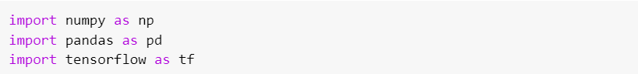
- Load dataset
We are going to use the dataset “Churn_Modelling” from the finance domain. There are 14 dimensions and 100000 records in it. Here our main goal is to create an artificial neural network that will take into consideration all independent variables (first 13) and based on that will predict if our customer is going to exit the bank or not (Exited - Represents if a customer is going to exit the bank or not is dependent variable here).
Dataset link: https://www.kaggle.com/code/bhaveshvss/churn-modelling-ann/data
- Generating Matrix of Independent Variables (X) and Dependent Variable Vector(Y) using the data.iloc method
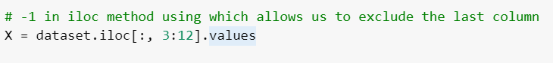
The first 3 columns i.e RowNumber, CustomerId, and Surname have nothing to do with deciding whether the customer is going to exit or not. Hence, in this case we started fetching all the values from the 3rd column onwards.

- Encoding Categorical Variable ‘Gender’ using LabelEncoder: Here our gender column has only 2 categories which are male and female, we are going to use LabelEncoding. This type of encoding will simply convert this column into a column having values of 0 and 1. To use Label Encoding, we are going to use LabelEncoder class from sklearn library.
- Implement OneHotEncoder using ColumnTransformer class from the same ScikitLearn library to encode the ‘Country’ feature
- Splitting dataset into training and testing dataset
- Performing Feature Scaling on both training and testing sets
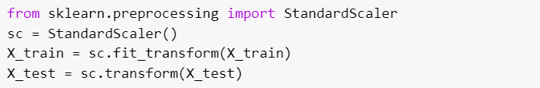
- Initializing Artificial Neural Network
This is the very first step while creating ANN. Here we are going to create our ann object by using a certain class of Keras named Sequential.
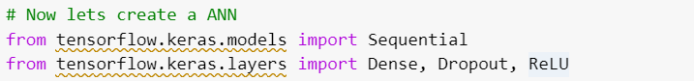
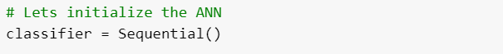
As a part of tensorflow 2.0, Keras is now integrated with tensorflow and is now considered as a sub-library of tensorflow. The Sequential class is a part of the models’ module of Keras library which is a part of the tensorflow library now.
Once we initialize our ann, we are now going to create layers for the same. Here we are going to create a network that will have 2 hidden layers, 1 input layer, and 1 output layer. So, let’s create our very first hidden layer
- Adding input layer to the Artificial Neural Network
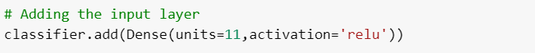
- Adding Hidden Layers to the Artificial Neural Network
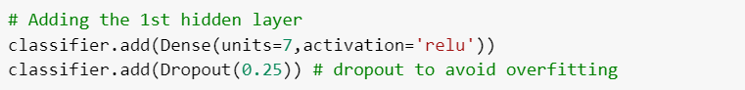
Here, we have created our first hidden layer by using the Dense class which is part of the layers module. This class accepts 2 inputs:
- units: Number of neurons that will be present in the respective layer
- activation: Specify which activation function to be used
Since we are going to create two hidden layers, this same step we are going to repeat for the creation of the second hidden layer as well.
- Adding Output Layer to the Artificial Neural Network
In this step, we are going to create our output layer for ann. The output layer will be responsible for giving output.
Here again, we are going to use the Dense class in order to create the output layer. Two important things to remember here:
1. In a binary classification problem (like this one) where we will be having only two classes as output (1 and 0), we will be allocating only one neuron to output this result. For the multiclass classification problem, we must use more than one neuron in the output layer. For example – if our output contains 4 categories then we need to create 4 different neurons [one for each category].
2. For the binary classification Problems, the activation function that should always be used is sigmoid. For a multiclass classification problem, the activation function that should be used is softmax.
Here, since we are dealing with binary classification hence, we are allocating only one neuron in the output layer and the activation function which is used is sigmoid.
- Compiling Artificial Neural Network
In this step, we are going to compile our ANN.
We have used compile method of our ann object to compile our network. Compile method accepts the below inputs:
- optimizer: specifies which optimizer to be used in order to perform stochastic gradient descent.
- loss: specifies which loss function should be used. For binary classification, the value should be binary_crossentropy. For multiclass classification, it should be categorical_crossentropy.
- metrics: which performance metrics to be used in order to compute performance. Here we have used accuracy as a performance metric.
- Fitting Artificial Neural Network
This is the last step in our ann creation process. Here we are just going to train our ann on the training dataset.

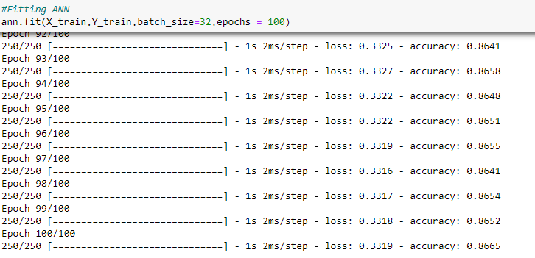
Here we have used the fit method to train our ann. The fit method is accepting 4 inputs in this case:
1.X_train: Matrix of features for the training dataset
2.Y_train: Dependent variable vectors for the training dataset
3.batch_size: how many observations should be there in the batch. Usually, the value for this parameter is 32 but we can experiment with any other value as well.
4. epochs: How many times neural networks will be trained.
14. Save your trained model using the following code

15. Predicting the results of trained model on test dataset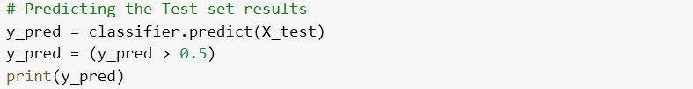

16. Evaluate your model’s accuracy

Experiment 13: Design and Implementation of Deep Neural Networks for Image Classification
Objectives:
To understand the architecture of deep neural networks and learn how to build, train, and evaluate a DNN using TensorFlow/Keras for image classification tasks.
Time Required : 3 hrs
Programming Language : Python
Software Required : Anaconda
Introduction
Deep Neural Networks (DNNs) are an extension of simple neural networks where multiple hidden layers are added between the input and output layers. These models are capable of capturing complex patterns in large datasets and are widely used in computer vision, natural language processing, speech recognition, and many more domains.
Each layer in a DNN applies a transformation to its input and passes the result to the next layer. The key strength of DNNs lies in their ability to learn hierarchical representations from data — from low-level features like edges to high-level concepts like shapes or objects.
In this lab, you will build a deep neural network to classify images from the Fashion MNIST dataset, which contains grayscale images of clothing items, such as shirts, shoes, and bags.
Dataset:
Fashion MNIST Dataset
- Training images: 60,000
- Testing images: 10,000
- Image size: 28x28 pixels, grayscale
- Number of classes: 10 (e.g., T-shirt/top, Trouser, Pullover, etc.)
Lab Tasks:
Task 1: Data Loading and Exploration
- Load the Fashion MNIST dataset using TensorFlow/Keras.
- Visualize at least 10 random samples from the dataset with their corresponding labels.
- Summarize the dataset shape and number of classes.
Task 2: Data Preprocessing
- Normalize the pixel values to fall in the range [0, 1].
- Convert class labels to categorical format using one-hot encoding.
- Split the dataset into training and validation sets.
Task 3: Model Architecture Design
- Design a deep neural network with at least:
  - Input layer matching the image dimensions
  - Two or more hidden layers with ReLU activation
  - A dropout layer to prevent overfitting
  - An output layer with softmax activation (for multi-class classification)
- Display a summary of the model architecture.
Task 4: Model Compilation
- Compile the model using:
  - Categorical crossentropy loss function
  - An appropriate optimizer (e.g., Adam)
  - Accuracy as the evaluation metric
Task 5: Model Training
- Train the model using training data.
- Set validation split for monitoring generalization.
- Use callbacks (e.g., EarlyStopping or ModelCheckpoint) if desired.
Task 6: Model Evaluation and Visualization
- Evaluate the model on the test dataset.
- Generate and visualize a confusion matrix.
- Plot training and validation loss/accuracy curves.
Task 7: Reflection and Improvement
- Discuss how deeper or wider networks might affect performance.
- Suggest any improvements (e.g., regularization, batch normalization).
- Comment on potential overfitting or underfitting in your model.

Experiment 14: Building and Training Custom Neural Networks with TensorFlow Datasets
Objectives:
To understand the process of building custom neural network models using TensorFlow’s functional and subclassing APIs, and to implement efficient data loading and preprocessing pipelines for training deep learning models.
Time Required : 3 hrs
Programming Language : Python
Software Required : Anaconda
Introduction
TensorFlow offers flexible tools to build and train custom deep learning models through its tf.keras.Model subclassing API. This approach allows you to define your model architecture manually, giving full control over the forward pass. It's highly useful for research, experimentation, and when implementing complex models not supported by default layers or sequential APIs.
Additionally, handling and preprocessing data efficiently is crucial for building high-performance ML pipelines. TensorFlow's tf.data API enables the creation of input pipelines that are scalable, reusable, and optimized for performance. It supports operations such as shuffling, batching, prefetching, and custom preprocessing.
In this lab, you'll learn to:
- Build a custom deep learning model using subclassing in TensorFlow.
- Implement custom training loops using GradientTape.
- Load, preprocess, and prepare datasets using tf.data.
Dataset:
CIFAR-10 Dataset
CIFAR-10 is a widely used dataset consisting of 60,000 32x32 color images in 10 classes, with 6,000 images per class. The dataset is divided into 50,000 training images and 10,000 test images. The 10 classes are: airplane, automobile, bird, cat, deer, dog, frog, horse, ship, and truck.

Lab Task:
Task 1: Data Loading and Preprocessing
- Load the CIFAR-10 dataset using tf.keras.datasets.cifar10.load_data().
- Normalize the image pixel values to range [0, 1].
- Convert the labels to one-hot encoded vectors.
- Use tf.data.Dataset to:
  - Convert the data to TensorFlow datasets.
  - Shuffle, batch, and prefetch the data.
  - Split into training and validation datasets.
Task 2: Build a Custom Neural Network
- Create a custom class by subclassing tf.keras.Model.
- Define the architecture:
  - Use Conv2D, MaxPooling2D, and Dense layers.
  - Add Dropout for regularization.
  - Use ReLU activation functions and Softmax for output.
- Implement the call() method to define the forward pass.
Task 3: Compile and Train the Model
- Define loss function (CategoricalCrossentropy) and optimizer (Adam).
- Train the model using either:
  - model.compile() and model.fit()
OR
  - A custom training loop using tf.GradientTape.
Task 4: Evaluate the Model
- Evaluate the model on the test dataset.
- Generate a classification report and confusion matrix.
- Plot training and validation loss/accuracy curves.
Task 5: Open-ended Exploration
You are encouraged to experiment by:
- Modifying the model architecture (e.g., adding more layers or using Batch Normalization).
- Changing the optimizer or learning rate.
- Applying data augmentation techniques like flipping, rotation, or cropping.
- Comparing training with and without dropout layers.

EXPERIMENT 15: Design and Implementation of Convolutional Neural Networks (CNN) for Image Classification

Objectives:
- To analyze and implement the architecture and operational principles of a CNN.
- To develop and apply a CNN model for solving image classification problems in real-world scenarios.
Time Required : 3 hrs
Programming Language : Python
Software Required : Anaconda
Introduction
Convolutional Neural Network is a Deep Learning algorithm specially designed for working with Images and videos. It takes images as inputs, extracts, and learns the features of the image, and classifies them based on the learned features.
It has various layers, and each layer has its own functioning i.e., each layer extracts some information from the image or any visual and at last all the information received from each layer is combined and the image/visual is interpreted or classified.
Similarly, CNN has various filters, and each filter extracts some information from the image such as edges, different kinds of shapes (vertical, horizontal, round), and then all of these are combined to identify the image.
Now, the question here can be: Why can’t we use Artificial Neural Networks for the same purpose? This is because there are some disadvantages with ANN:
- It is too much computation for an ANN model to train large-size images and different types of image channels.
- The next disadvantage is that it is unable to capture all the information from an image whereas a CNN model can capture the spatial dependencies of the image.
- Another reason is that ANN is sensitive to the location of the object in the image i.e if the location or place of the same object changes, it will not be able to classify properly.
Components of CNN
The CNN model works in two steps: feature extraction and Classification
Feature Extraction is a phase where various filters and layers are applied to the images to extract the information and features out of it and once it’s done it is passed on to the next phase i.e. Classification where they are classified based on the target variable of the problem.
A typical CNN model looks like this:
- Input layer
- Convolution layer + Activation function
- Pooling layer
- Fully Connected Layer
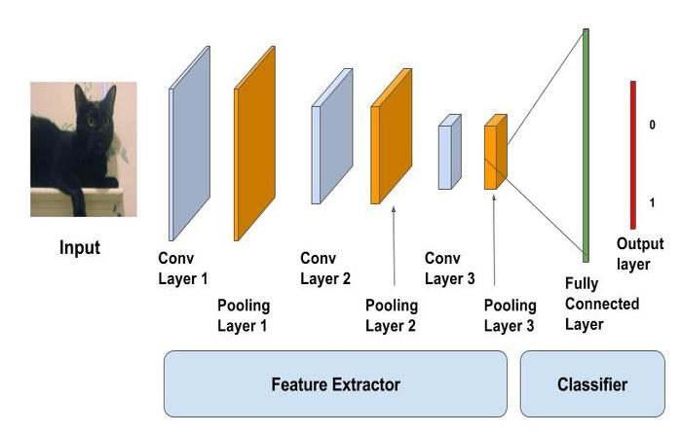
Input layer
As the name says, it’s our input image and can be Grayscale or RGB. Every image is made up of pixels that range from 0 to 255. We need to normalize them i.e. convert the range between 0 to 1 before passing it to the model.
Below is the example of an input image of size 4*4 and has 3 channels i.e. RGB and pixel values.
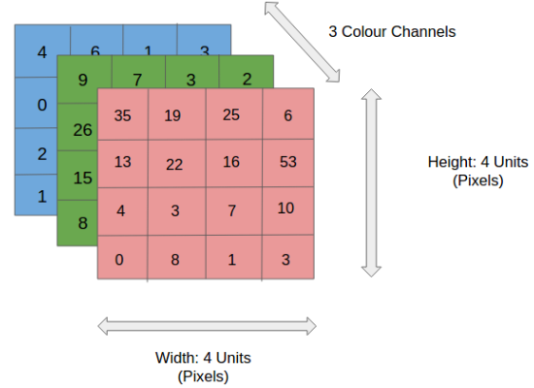
Convolution Layer
The convolution layer is the layer where the filter is applied to our input image to extract or detect its features. A filter is applied to the image multiple times and creates a feature map which helps in classifying the input image. Let’s understand this with the help of an example. For simplicity, we will take a 2D input image with normalized pixels.
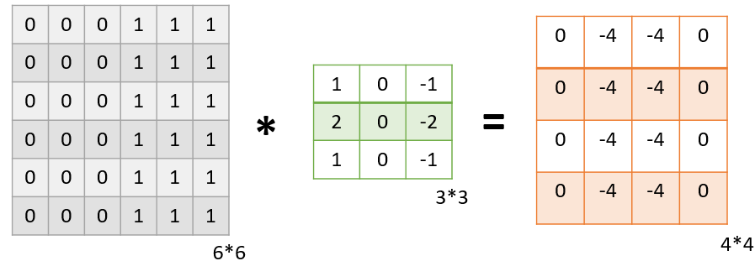
In the above figure, we have an input image of size 6*6 and applied a filter of 3*3 on it to detect some features. In this example, we have applied only one filter but in practice, many such filters are applied to extract information from the image.
The result of applying the filter to the image is that we get a Feature Map of 4*4 which has some information about the input image. Many such feature maps are generated in practical applications.
Let’s get into some math’s behind getting the feature map in the above image.
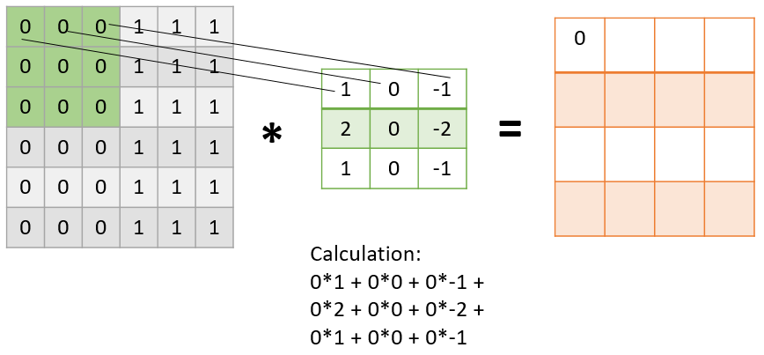
As presented in the above figure, in the first step the filter is applied to the green highlighted part of the image, and the pixel values of the image are multiplied with the values of the filter (as shown in the figure using lines) and then summed up to get the final value.
In the next step, the filter is shifted by one column as shown in the below figure. This jump to the next column or row is known as stride and in this example, we are taking a stride of 1 which means we are shifting by one column.
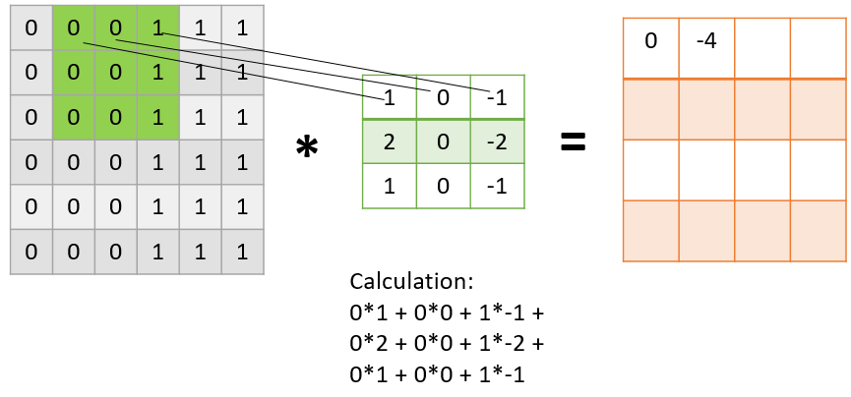
Similarly, the filter passes over the entire image and we get our final Feature Map. Once we get the feature map, an activation function is applied to it for introducing nonlinearity.
A point to note here is that the Feature map we get is smaller than the size of our image. As we increase the value of stride the size of the feature map decreases.
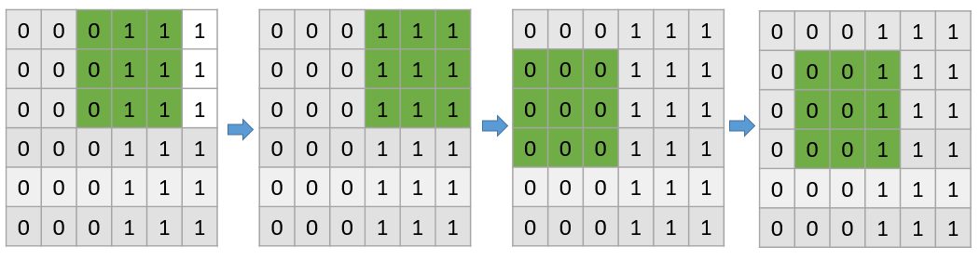
This is how a filter passes through the entire image with the stride of 1
Pooling Layer
The pooling layer is applied after the Convolutional layer and is used to reduce the dimensions of the feature map which helps in preserving the important information or features of the input image and reduces the computation time.
Using pooling, a lower resolution version of input is created that still contains the large or important elements of the input image.
The most common types of Pooling are Max Pooling and Average Pooling. The below figure shows how Max Pooling works. Using the Feature map which we got from the above example to apply Pooling. Here we are using a Pooling layer of size 2*2 with a stride of 2.
The maximum value from each highlighted area is taken and a new version of the input image is obtained which is of size 2*2 so after applying Pooling the dimension of the feature map has reduced.
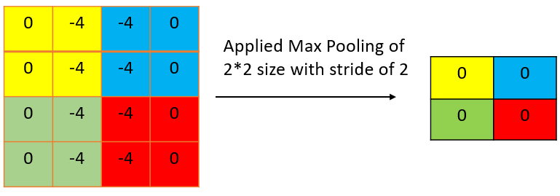
Fully Connected Layer
Till now we have performed the Feature Extraction steps, now comes the Classification part. The Fully connected layer (as we have in ANN) is used for classifying the input image into a label. This layer connects the information extracted from the previous steps (i.e Convolution layer and Pooling layers) to the output layer and eventually classifies the input into the desired label.
The complete process of a CNN model can be seen in the below image.
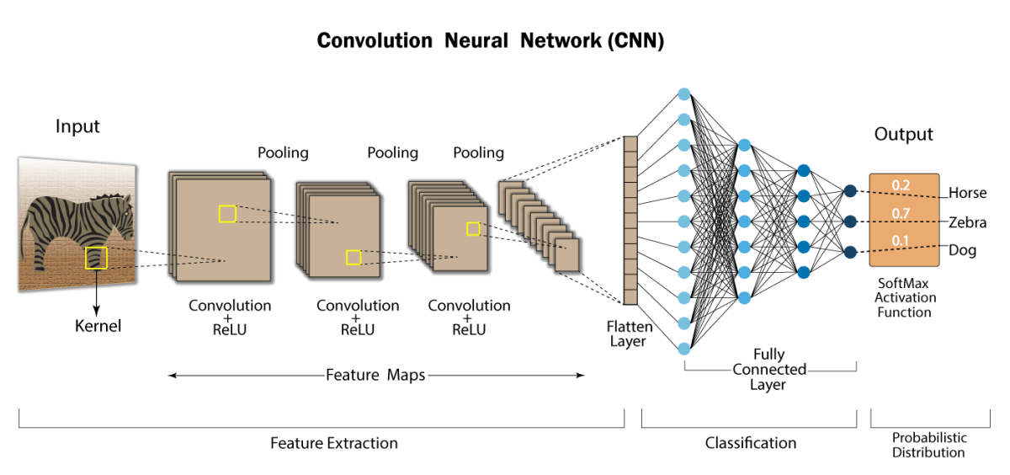
Lab Task:
Build a Convolutional Neural Network (CNN) model using Tensorflow to recognize handwritten digits.

EXPERIMENT 16 : Advanced Implementation of Classification and Localization using Convolutional Neural Networks (CNNs)

Objectives:
To understand how Convolutional Neural Networks can be used not just for image classification, but also for object localization by predicting both the object class and its bounding box coordinates in an image.
Time Required : 3 hrs
Programming Language : Python
Software Required : Anaconda
Introduction
Convolutional Neural Networks (CNNs) are widely used for computer vision tasks due to their ability to capture spatial hierarchies in images. While classification assigns a label to an entire image (e.g., identifying if an image contains a cat), localization goes a step further by also predicting the location of the object using a bounding box (usually defined by [x, y, width, height]).
This lab introduces students to a simple object detection task that combines both classification and localization. Unlike full-fledged object detection models (like YOLO or SSD), we will build a basic CNN that predicts:
- The class of the object in the image.
- The coordinates of a bounding box that localizes the object.
This hybrid output model introduces the concept of multi-output neural networks.
Dataset:
We will use a simplified custom object detection dataset containing small images (e.g., 128x128 pixels) of various geometric shapes (circle, square, triangle) placed at random positions. Each image is labeled with:
- label: Class of the object (circle, square, triangle)
- bbox: A list containing bounding box coordinates [x_min, y_min, width, height]
You can use or generate a small synthetic dataset or use an open-source version such as Kaggle's Shapes dataset (or create your own using basic drawing libraries like PIL or OpenCV).

Lab Task:
Task 1: Data Loading and Visualization
- Load the dataset and understand its structure.
- Visualize a few samples along with their bounding boxes.
- Verify that labels and bounding boxes are correctly aligned with images.
Task 2: Data Preprocessing
- Normalize image pixel values.
- Convert class labels to one-hot vectors.
- Normalize bounding box coordinates (optional but recommended).
- Split the dataset into training and validation sets.
Task 3: Build a Multi-output CNN Model
- Construct a CNN architecture that has:
  - One output layer for classification (softmax activation).
  - One output layer for bounding box regression (linear activation).
- Compile the model using appropriate loss functions:
  - Categorical Crossentropy for classification.
  - Mean Squared Error (MSE) for bounding box regression.
Task 4: Train the Model
- Train the model using the training set.
- Plot training and validation loss curves for both classification and localization.
Task 5: Evaluate the Model
- Evaluate the model on the validation set:
  - Report classification accuracy.
  - Report bounding box regression error.
- Visualize predictions by plotting bounding boxes on predicted images.
Task 6: Discuss Potential Improvements
- Suggest how this simple model could be improved for better accuracy and performance.
- Briefly explain how advanced models (YOLO, SSD, Faster R-CNN) handle classification and localization simultaneously.

COMPLEX ENGINEERING PROBLEM - MACHINE LEARNING

INSTRUCTOR: Dr. Hammad Afzal
COURSE CODE: CS-471
SEMESTER: 7th (Fall, 2023)
Credit Hours: 03 (Theory)+ 1 (Lab)

Semester project is designed in a way to able students to solve the complex engineering problem. Following characteristics of complex engineering problem are targeted in this semester project of Machine Learning:

WP-1  Depth of Knowledge Required |  | WP3 Depth of Analysis Required | WP-4 Familiarity of Issues
CLO | WA/PLO | Definition: Have no obvious solution and require abstract thinking, originality in analysis to formulate suitable models. | Definition: Involve infrequently encountered issues.
CLO-2  CLO-3 | PLO-4  PLO-5 | Exploratory Data Analysis Techniques to show the initial insights into different variables | What types of attributes are more suitable to be used in ML models

Note:
Total Number of WPs are 7. For any particular CEP, WP-1 is mandatory, and Some or All of WP-2 to WP-7 can be used.
Objective:
The objective of this assignment is to develop a machine learning model to predict employee attrition in a company based on a provided dataset. Students will work on a binary classification Task, and the assignment includes preprocessing, exploratory data analysis (EDA), model selection, and evaluation.
Dataset:
The dataset contains various features related to employees in a software engineering company, and the target variable is "Attrition," indicating whether an employee has left the company (1) or is still with the company (0).
Dataset is available at:
https://github.com/nelson-wu/employee-attrition-ml/blob/master/WA_Fn-UseC_-HR-Employee-Attrition.csv
Tasks:
Data Preprocessing:
Handle missing data by either imputation or removal of incomplete records.
Encode categorical variables appropriately.
Scale numerical features to ensure uniformity.
Explore and handle any outliers or anomalies in the data.
Exploratory Data Analysis (EDA):
Conduct a thorough analysis of the dataset to understand its characteristics.
Visualize the distribution of employees with respect to different features.
Analyze the correlation between various features and attrition.
Identify patterns or trends that may influence employee attrition.
Attrition Prediction:
Split the dataset into training and testing sets.
Choose an appropriate machine learning algorithm for binary classification (e.g., Logistic Regression, Random Forest, or Decision Tree).
Train the model on the training set.
Evaluate the model on the testing set and report performance metrics such as accuracy, precision, recall, and F1 score.
Model Improvement (Optional):
Experiment with different hyperparameters or feature selection techniques to improve model performance.
Consider using techniques such as cross-validation to fine-tune the model.
Documentation:
Create a single presentation slide (like a poster) (i) Document your approach, including the preprocessing steps, choice of model, and any adjustments made. (ii) summarizing your findings, challenges faced, and the overall performance of your machine learning model.
Note:
Feel free to use any popular machine learning libraries (e.g., scikit-learn, TensorFlow, PyTorch) and visualization tools (e.g., Matplotlib, Seaborn) in your implementation. Ensure that your code is well-commented and your documentation is clear and organized.
Deliverables:

Items | CLOs | Marks
Jupyter Notebook or Python script containing the code. | CLO2, CLO3 | 10
Preprocessing, EDA, Visualization | CLO2, CLO3 | 40
Prediction, Cross Validation | CLO2, CLO1 | 30
A presentation slide deck summarizing key findings and insights. | CLO3 | 10
Creativity and innovation in addressing challenges. | CLO1, CLO2 | 10

Mapping of CLO to WA/PLO from First Day Handout

